**CHAPTER 3. Hardware**

Primary Storage

* RAM(Volatile Memory)- Random Access Memory

-SRAM-Static RAM -cache on CPU (made by flip-flop(触发器))

-DRAM-Dynamic RAM -内存条 Main Memory （Made by capacitor(电容器)）

* ROM(non-volatile memory) - Read Only Memory

ROM(CAN'T CHANGE) -> P(Programmable)ROM -> E(Erasable)PROM (UV LIGHT)-> E(Electronically)EPROM

EEPROM ADVANTAGES/USES

* (can be erased and reprogrammed serveral times)
* （firmware can be updated）
* (without removing it from the device)

CONTAIIN/SAVE A BOOT-UP PROGRAM

* BIOS

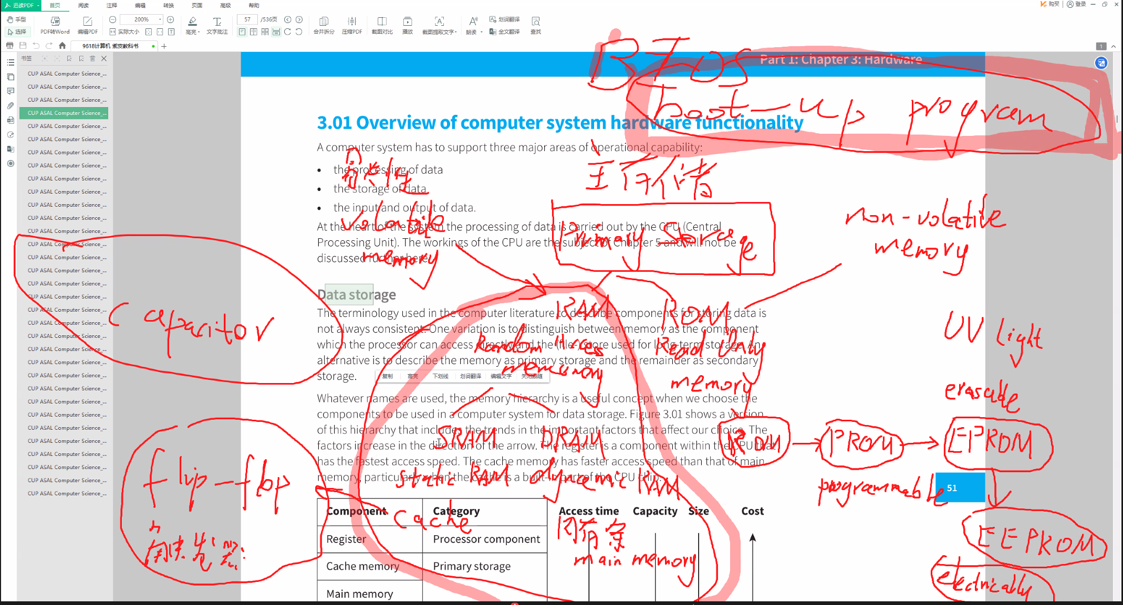

Secondary Storage

* harddisk SD TF usb-drive CD/PVD/blu-rag

Embedded systems: OPERATE Specific function

CONSTRUCTED ON ONE CHIP

BUFFERS（a temporary storage）

coordinate data transfer speed mismatch

hard disk

* Mechanic Magnetic Media Harddisk

PRINCIPLE OPERATION OF MAGNETIC HARDDISK

* The hard disk has (one or more) platter
* Each surface of the platter is (ferrous oxide which is) capable of being magnetised
* Each surface of the platter has a read/write head mounted on an arm
* Electronic circuits control the movement of the arm
* The surface of the platter is devided into sectors, One sector is the basic unit or storage

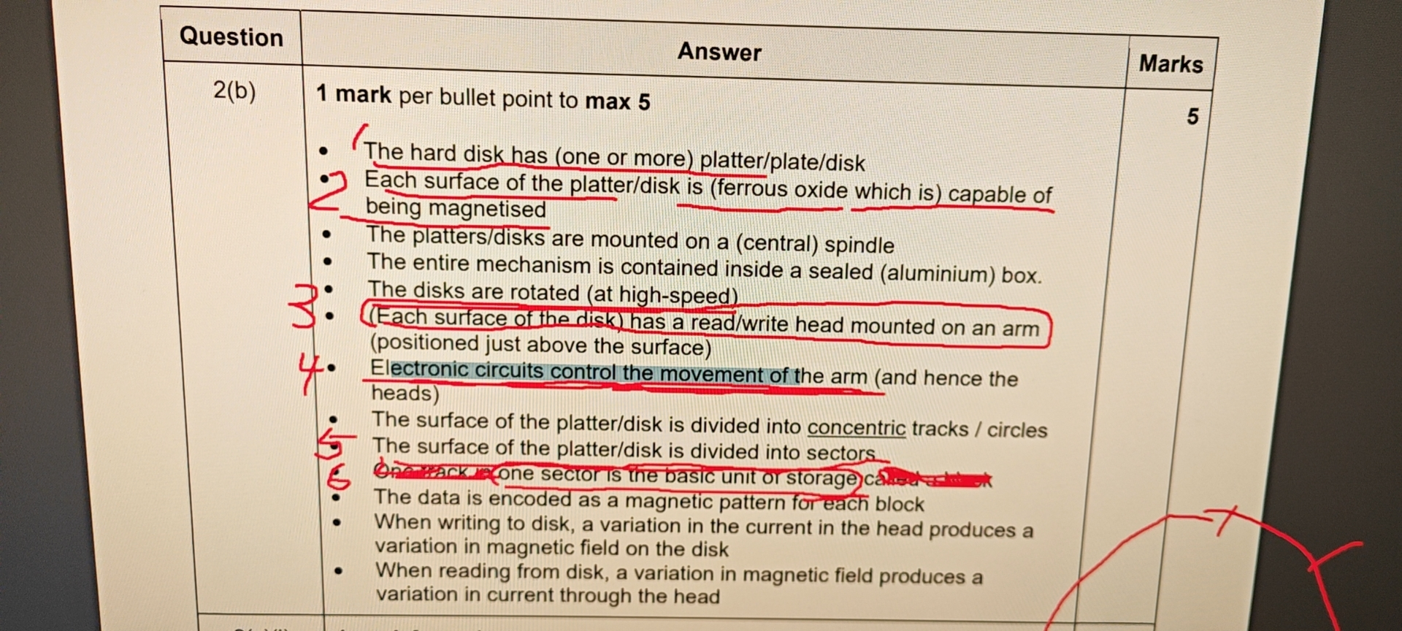

SSD: SOLID-STATE DISK - The basis for this is 'flash' memory which is a semiconductor technology with no moving parts

ADVANTAGES:

* faster
* quiet
* more reliable

Optical Media:

The reflective surface is a special alloy material. When data is being written to the disc (the 'burn' process) the heat generated by the absorption of the laser light changes the material to liquid form. Depending on the intensity of the laser light the material reverts to either a crystalline or an amorphous solid form when it cools.When the disc is read, the laser light is reflected from the crystalline solid but not from the amorphous solid, allowing the coding of a 1 or 0.

-Output-

Screen display:

Liquid-crystal display(LCD):a screen back-lit by light-emitting diodes and with liquid crystal cells sandwiched between polarisers

laser printer:

* Drum is initially given an electrical charge
* A laser beam scans back and forth across the drum
* discharging certain points
* The drum is coated with oppositely charged toner
* The drum rolls over electro-statically charged paper
* The 'pattern' on the drum is transferred to the paper
* The paper is passed through the fuser to seal the image
* The electrical charge is removed from thre drum, the excess toner is collected

Hard-copy output of text:

* The paper is moved forward a fraction and the printhead moves across the paper again.This continues until the sheet has been fully printed.The printhead consists of nozzles that spray droplets on to the paper.Ink is supplied to the printhead from one or more ink cartridges

3D-Printer:

computer-aid design (CAD) pakage - e.g. autocard

The design is split into layers.The data for the first layer is transmitted to the 3D printer

3D printer uses a nozzle to squirt material on to the printer bed.

This process is repeated for successiive layers.

-Input-

keyboard:

* The key matrix is a grid of circuits
* Each circuit is broken beneath the key
* When key pressed, a circuit is (made/coompleted) and a signal is sent
* Keyboard processor compares the electrical signal to the correct character encoding stored on ROM(KEYBOARD)
* sent to the computer

scanner and camera... (input of graphic):

* Main component of a scanner is a charged-coupled device(CCD) array
* CCD is a collection of light sensitive diodes
* light shines onto the source document
* sensors detect levels of reflected light
* Brighter light results in greater electrical charge
* Light intensity is converted (by software) to a digital value

-TOUCH SCREEN-

resistive touch screen:

a flexible surface that causes contact between electrically resistive layers beneath when touched

capacitive touch screen:

a rigid surface above a conductive layer that undergoes a charge in electrical state when a finger touches the screen, support multi-touch

The screen has a layer that stores an electrical charge.

When the user touches the screen.

There is a change in the electrostatic field.

Charge is drawn to the point of contact.

The coordinates are sent to the touchscreen driver

The coordinates of the point of contact can be calculated

-INPUT AND OUTPUT OF SOUND-

INPUT(PRINCIPLE OF MICROPHONE):

Microphone, a device that has a diaphragm, is caused to vibrate by an incoming sound,

If the diaphragm is connected, the vibration causes a change in an electrical signal

The analogue electrical signal is converted to a digital signal by an analogue-to-digital(ADC)

converter so that it can be processed inside the computer

OUTPUT(PRINCIPLE OF LOUDSPEAKER):

Digital data from the computer system is converted to analogue by a digital-to-analogue (DAC) converter.The analogue signal is fed as a varying electrical current to the speaker.The current flows through a coil suspended within the magnetic field provided by a permanent magnet in the speaker.As the size and direction of the current keep changing, the coil moves backwards and forwards.This movement controls the movement of a diaphragm, which causes sound to be created